**AZURE PREPARATION**

Very Important link for Azure fundamentals <https://www.sharepointcafe.net/2021/08/exam-az-900-notes.html>

--- Good video for SQL database migration to Azure <https://youtu.be/MhnmG-cHrKM> ------

<https://docs.microsoft.com/en-us/sql/sql-server/migrate/dma-azure-migrate-compare-migration-tools?view=sql-server-ver16> --- Different tools available for Migration..

Online and offline Migration for Azure Managed instance Microsoft Link :

<https://docs.microsoft.com/en-us/azure/dms/tutorial-sql-server-managed-instance-offline-ads>

<https://docs.microsoft.com/en-us/azure/dms/tutorial-sql-server-to-virtual-machine-online-ads>

Also we have lift and shift option in Azure.

<https://www.youtube.com/watch?v=L8YdX2PKPVA> ( Assesment using the DMA tool for Azure SQL database and Azure SQL datatabase managed instance)

Mainly if we user DMA ( Data Migration Assistance ) then we can upgrade the current to the

Next version we can asses the compatibility issues as well and same version also we can migrate

For DMS ( Data Migration Service with Azure Data Studio Tool) then main benefit is

We can have online and offline Migration….

<https://docs.microsoft.com/en-us/azure/azure-sql/azure-sql-iaas-vs-paas-what-is-overview?view=azuresql> -- Differences of Azure SQL and MI --- V.IMP

Always on Azure --- <https://www.youtube.com/watch?v=ijX9P9-cvx8>

( In Always-on we need to create internal Load balancer to have connection between nodes after failover)

Day to Day Activities we do for Azure SQL for interview purpose, Please mention Some Points:

Maintenance activities and check in Google about what exactly we can configure alerts for Azure monitoring…..

We will be getting Alert tickets\Mails of blockings and CPU, long running queries and database size limit crosses thresholds and we will work on that accordingly…

We will configure geo replication and we will do if any auto scaling is required

And we will create elastic jobs

We will work on any Fragmentation is required on db’s

We will work on migrating databases from on-prem to Azure..

Azure Doubts :

---- what is cloud ?

cloud is a Virtual Environment used to host any data or Apps (software

Easy, Secured and Faster access using URLs and Tools

----- what are the benefits of cloud ?

Answer :

High Availability and DR.

Scalability and Elasticity.

Faster access to the Data.

No Physical infrastructure is involved. Hence, Low Maintainence overhead

Easy Networking configuration[virtual Networks]

1) is SQL database and SQL managed instance are Paas offered concept and Virtual machines are iaas offered concepts ?

Answer : Yes

2) if we choose Iaas model for our migration of on-prem to Azure then the operational support of Azure SQL VM's are same like we support

And Azure MI paas model ,,,, No Windows but we can have cross queries between db’s and SQL agents

But for Azure SQL database ,,, No windows , No cross queries and No SQL agents. We can configure jobs using elastic job…etc

We have Geo Replication for HA option for Azure MI and Azure SQL database Paas services.

<https://docs.microsoft.com/en-us/azure/azure-sql/database/active-geo-replication-configure-portal?view=azuresql&tabs=portal>

--- we can change the backup Retention in Portal -----

<https://docs.microsoft.com/en-us/azure/azure-sql/database/long-term-backup-retention-configure?view=azuresql&tabs=portal>

How to manage Fragmentation for Azure DB’s

<https://docs.microsoft.com/en-us/archive/blogs/dilkushp/fragmentation-in-sql-azure>

how to check Database size in Azure SQL : The portal shows only the data size. Sp_Spaceused show the total size including the log file size. **You can use the reserved space shown on sp_spaceused to measure the current size**. The log file size is not calculated in the total limit for the database.

How to use elastic pool for increasing resources like disk size,cpu,memory…etc

Answer : <https://www.youtube.com/watch?v=nzl0FmAix14>

<https://docs.microsoft.com/en-us/azure/azure-sql/database/elastic-pool-manage?view=azuresql>

the above link is for we have power shell scripting on how to create\manage\delete elastic pools.

So please learn power shell for the above and index maintenance so that you can tell you are having a bit experience in power shell aswell.

We can create the elastic pool and add the multiple databases from the same server if you want other Server databases then you may need to create multiple elastic pools…

But if you want you can create multiple pools for the same server then you can create if required…..

Also elastic pool size limit is depending on the premium type of Basic,standard and premium

For DTU and Data Size and Databases adding limit…etc Also we can limit the size per database limit

How to use elastic jobs for automation task ?

Answer : However, to enable Elastic Agent Job you need **at least Standard S0 level** which has at least DTU 10. It is important to remember that the Elastic Job feature will not be available for Azure SQL Managed Instance.

And also we have to create the elastic job which will create the new database which will be empty database but with some default objects will be created and we used to create the jobs using the scripts and also we need credential to run and will create the same while creating the job.

Select * from job.jobsexecution if you run it the you will find what all are running and available

<https://www.youtube.com/watch?v=VKCjFESV9IM> – Nice links to configure, monitor the elastic job

--- elastic for index maintenance job : <https://www.sqlshack.com/automating-azure-sql-database-index-maintenance-using-elastic-job-agents/>

Also we can only install the elastic job from Azure and then we have to execute the T-sql and monitor the jobs through SSMS only and we can view the basic status of jobs in Azure portal

**Collation Setting in Azure** : we can able to select the required collation as per the bussiness requirement while creating the Azure Sql db but after creation we can’t able to Alter the collation

And if we are migrating db from on prem to Azure and want to change collation then we have few steps : see below link

<https://www.sqlshack.com/how-to-change-an-azure-sql-database-collation/#:~:text=Azure%20SQL%20DB%20does%20not,you%20try%20to%20change%20it.&text=Suppose%20you%20are%20deploying%20an,collation%20in%20the%20target%20database>.

3) i heard there is no secondary file (mdf and ldf) concept in Azure, is that correct ?

Answer : for Paas enviroments,,,, it is true

4) i heard there is no windows login concept in Azure and only (SQL authentication and Azure Active directory login concepts exists) is that true ?

Answer : yes but only for paas

5) how the elasticity works if we need sudden requirement of space or CPU's ...etc

Answer : we can scale anything up and down with minimum downtime ( depending up on the what service tier we are doing that)

You may find that your workload's queries and indexes are properly tuned, or that performance tuning requires changes that you cannot make in the short term due to internal processes or other reasons. Adding more CPU resources may be beneficial for these databases. You can [scale database resources with minimal downtime](https://docs.microsoft.com/en-us/azure/azure-sql/database/scale-resources?view=azuresql).

You can add more CPU resources to your Azure SQL Database by configuring the vCore count or the [hardware configuration](https://docs.microsoft.com/en-us/azure/azure-sql/database/service-tiers-sql-database-vcore?view=azuresql#hardware-configuration) for databases using the [vCore purchasing model](https://docs.microsoft.com/en-us/azure/azure-sql/database/service-tiers-sql-database-vcore?view=azuresql).

Under the [DTU-based purchasing model](https://docs.microsoft.com/en-us/azure/azure-sql/database/service-tiers-dtu?view=azuresql), you can raise your service tier and increase the number of database transaction units (DTUs). A DTU represents a blended measure of CPU, memory, reads, and writes. One benefit of the vCore purchasing model is that it allows more granular control over the hardware in use and the number of vCores. You can [migrate Azure SQL Database from the DTU-based model to the vCore-based model](https://docs.microsoft.com/en-us/azure/azure-sql/database/migrate-dtu-to-vcore?view=azuresql) to transition between purchasing models.

<https://docs.microsoft.com/en-us/azure/azure-sql/database/scale-resources?view=azuresql>

the above link is having the impact of scaling and alternative solutions please search…

6) what database permission roles exists for DB users in Azure ?

Ansewer : MI : Same , VM : Same and ASD : there are three server level

Server level principle accounts equivalent to SA

And login manager for managing logins and db manager – create\drop databases in master.

As soon as we create the databases in Azure the first main step is we need to enable the fire wall

For our ip or range…etc

Also please make sure that what ever we are creating SQL login or AD account then we have to

Create it in master database in Azure SQL db as well and then create the user in database level

And you can grant roles to the user using T-SQL in SSMS.

And for Active directory accounts then we can Add the users\Groups in Azure Active directory

And then create the user using the T-SQL in SSMS using below command

Create user [AD Account user\group] FROM EXTERNAL PROVIDER in master DB

And then add db roles to the Azure AD account.

Imp Note is : when we need to create the login Azure databases then please make sure that

We have to set the AD account as admin account for that logical server in portal and connect the SSMS using the AD account and then you can add the AD account users in SSMS and grant permissions..

AD account then only we can add AD accounts

<https://www.youtube.com/watch?v=IJpXwaPRYUE> – Nice link for Access only first 10 mins for SQL login

<https://www.youtube.com/watch?v=hUOQRc0s7fI> – Azure AD

7) how can we perform the restore\refresh and the existing database in Azure like (Azure SQL test db to Azure prod db) ? and how we will do PITR and also how to take manual backup ?

Answer : in paas using the portal or power shell the backup path will be in URL

( you can read all the Important notes in the below link it is very nice )

<https://docs.microsoft.com/en-us/azure/azure-sql/database/recovery-using-backups?view=azuresql>

You can't overwrite an existing database during restore.

If you intend the restored database to be a replacement for the original database, you should specify the original database's compute size and service tier. You can then rename the original database and give the restored database the original name by using the [ALTER DATABASE](https://docs.microsoft.com/en-us/sql/t-sql/statements/alter-database-azure-sql-database) command in T-SQL.

Yes we can take manual backups from SSMS Export using BACPAC or DACPAC

Microsoft Blog : Both Azure SQL Database and Azure SQL Managed Instance use SQL Server technology to create [full backups](https://docs.microsoft.com/en-us/sql/relational-databases/backup-restore/full-database-backups-sql-server) every week, [differential backups](https://docs.microsoft.com/en-us/sql/relational-databases/backup-restore/differential-backups-sql-server) every 12-24 hours, and [transaction log backups](https://docs.microsoft.com/en-us/sql/relational-databases/backup-restore/transaction-log-backups-sql-server) every 5 to 10 minutes.



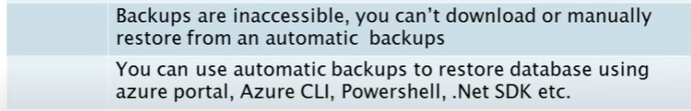

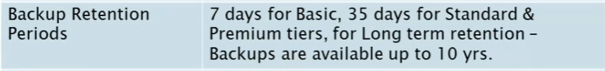

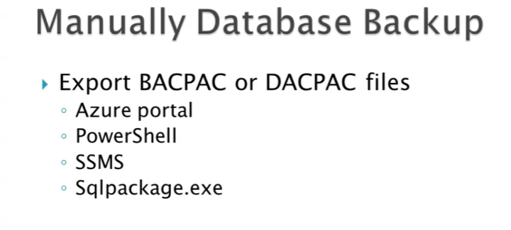

If we delete any database it will be available in the Deleted databases but if you delete the logical

Server then it won’t be available…

Also even if we need to restore the database from Azure backup’s we cannot overwrite the

Existing database in Azure and

8) Suppose if we choose the Azure sql database then how can we configure the application jobs ?

Answer : No SQL Agent but we can automate using Azure Automation Run books and/or Elastic jobs and/or windows Scheduler. Widely used one is Elastic jobs

10) i think Azure sql database\SQL managed instance all the maintainece jobs will be taking care by Azure itself then suppose if there is any failure or if we need to check the status

then where can we check.

Answer :

13) is there high availabilities concept for Azure SQL database\ SQL managed instance like Always on ?

Answer : Yes, Geo Replication

14) We don't have windows Authenticatin concept in Azure and having only SQL authentication and Active directory ?

Answer : Yes

15) Azure SQL database or SQL Managed instances are paas offered concepts and what ever we connect those are logical server names and we can't connect to the server ?

Answer : Yes

16) what is blob storage ?

Answer : Azure Blob storage is a feature of Microsoft Azure. It **allows users to store large amounts of unstructured data on Microsoft's data storage platform**. In this case, Blob stands for Binary Large Object, which includes objects such as images and multimedia files

17) is there any activities\monitoring that you need to perform for Azure SQL database or SQL MI ?

Answer : Azure service health and Azure monitor and Azure Pricing

<https://docs.microsoft.com/en-us/azure/azure-monitor/usage-estimated-costs>

Follow your [Azure Advisor best practice recommendations](https://azure.microsoft.com/en-us/services/advisor/) for cost savings, perfomance inprovement…etc

Azure service health :

21) what is Azure key vault services ?

* Answer : To store access secrets such as API Keys, Password, Certificates we can use Azure Key Vault.

22) what is Azure resource manager template ?

* Answer : ARM (Azure Resource Manager) Template is a to implement Infrastructure as a code in Azure. ARM template is a JSON based file which defines the infrastructure and related configuration. For example – You can create a VM and SQL Database of your required configuration from Azure portal, if you have been asked to create the same environment you have to repeat the same steps instead of doing that you can create ARM Template and create environment with same JSON file quickly.

23)what is the Azure Recovery services ?

Answer :

25) How you will monitor Azure pricing and which tool is being used ?

Answer :

26) how do we scaling and elastic the resources ?

Answer :There are 2 types of scaling – Vertical Scaling and Horizontal Scaling

Vertical Scaling – Increase the available hardware capacity for eg Increasing RAM size.

Horizontal Scaling – Allows to increase the instance of number of Virtual Machines

27) how you will monitor all the Azure VM’s and MI and Azure SQL databases ?

Answer : Looks we have Azure Monitor , search more in Google.

28) what is Azure advisor , Azure Monitor and Azure service health ?

Answer : you can read in link from first page.

30) how you will check for long running\blocking queries in Azure SQL \MI databases ?

Answer :

31) How you will configure mail notifications for database moniroting status of queries\locks ?

Answer :

32) do we have any downtime for Azure SQL DB’s or Azure MI ? if yes do we need to do anything from our side ?

Answer :

33) Azure SQL database pricing or Purchasing Modles ?

Answer : <https://www.youtube.com/watch?v=dWNyHMBrYJY>

There are two type DTU bases and Vcore based pricing model.

Below is DTU model :

In standard DTU Min ( for workloads and performance): 10 DTU and 250 GB and Max 3000 DTU and 1 TB

Premium ( for IO Best performance): Min :125 DTU and 1 TB and 4000 DTU and 4 TB.

Vcore Purchasing Model

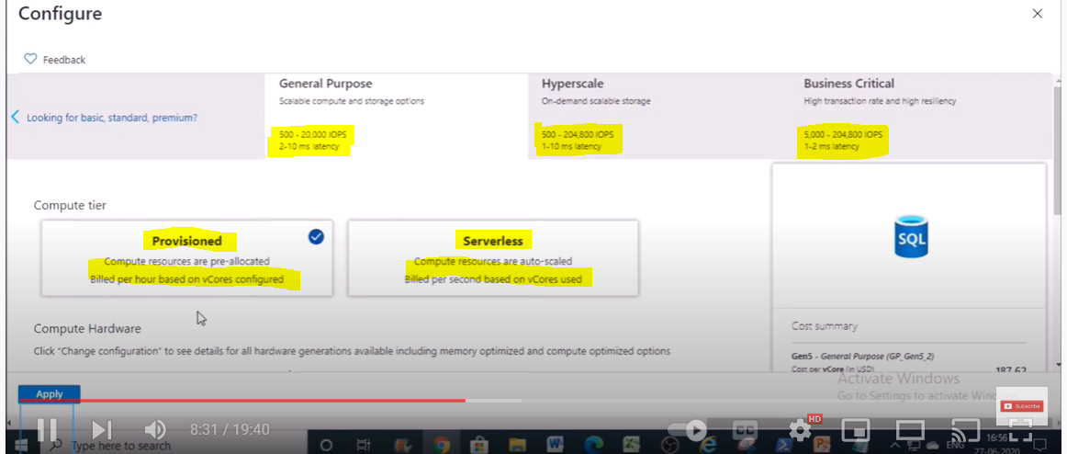

Below are the Points which we need to remember for Azure SQL data

34) How to create Alerts in Azure Monitor?

Answer : <https://www.youtube.com/watch?v=DaWSNilSAp0>

> Recovery model is full and you cannot change this

> Backup's ar automatically scheduled and taken and we cannot perform manual backup in Azure portal

But we can take it in local machine with BACPAC or DACPAC files…..

> we cannot download automated bacups but when you restore then only you can restore it by mentioning the time and also you can restore it only with new name and you cannot overwrite the Database.

> No SQL Agent but we can automate using Azure Automation Runbooks and/or Elastic jobs and/or windows Scheduler but widely used one is Elastic jobs for only Azure SQL DB’s

> for Azure MI we have SQL agent available for jobs configuration…

>Restore with overwrite is not supported on Azure SQL DB and MI. we have delete the database and then only we can restore

>Deleted database also can be restored on limit of it's retention period but once you delete the server not possible to restore the backup from portal

>By default , the database is Read_Commited_Snapshot isolation

>we can't enable trace flag in Azure SQL DB model

>we can't keep the database in Single user mode mode. this won't work

>we can't keep the database in offline mode. this won't work

> then how to stop the application connecting to database : is either you need to rename the database

or need to revoke the access for the application user by removing the firewall rules..